ONLINE RETAIL ORDERS DATASET (2023–2025)

Customer Behavior, Sales Trends, and Order Fulfillment

PROJECT OVERVIEW AND OBJECTIVE
The goal is to analyze customer purchasing behavior, product performance, pricing trends, and operational efficiency across the order lifecycle. Key business challenges include understanding demand patterns, identifying high-value customer segments, evaluating the impact of promotions and referrals, detecting fulfillment bottlenecks, and forecasting future sales volumes.

DATA SOURCES
- Source Description and Timeline : Indian Data Portal/ISB Sales & Production Dataset
- Time Period : 2023 - 2025.
- Domain : Sales & Production

PROBLEM STATEMENT
- What factors influence total order value?
- How do payment methods, referral sources, or coupon codes affect purchase decisions?
- Which products drive the highest revenue or order frequency?
- What patterns exist in cancellations, returns, or shipping behavior?
- How can the store optimize operations and improve customer retention?

ATTRIBUTE (COLUMN /FEATURES) DETAILS
ATTRIBUTE NAME | DATA TYPE | DESCRIPTION
Order ID | String (Text) | Unique identifier for Each Order
Year | Numeric (Year) | Purchase Year
Date | Date Format | Purchase date
Customer ID | String (Text) | Each Customer ID
Product | String (Text)) | Unique identifier for Each Product
Quantity | Numeric (Whole number) | Quantity of Purchase
Unit Price | Numeric (Whole number) | Unit Price of Each Product
Address | String (Text) | Unique identifier for Each Customer
Payment Method | Numeric (Decimal) | Unique Discount for every Products
Order Status | String (Text)) | Stage of each order
Tracking Number | Text and Number | Tracking ID of Order
Itemcart | Numeric (Whole number) | Excess product in cart
Coupon | String (Text) | Coupon for Discount
Referral Source | String (Text) | Social Media Referral
Total Price | Numeric (Decimal) | Total Price of Each Product

TOOLS & TECHNOLOGIES
- Excel: Data cleaning, transformation, and Pivot Tables.
- Power BI : Visualization and interactive dashboards creation.

DATA PRE-PROCESSING (EXCEL / POWER QUERY)

Tasks Performed
- Data Cleaning & Transformation: Removed duplicates, handled missing values, standardized formats, and created calculated fields.
- Filtering & Sorting: Organized data to focus on relevant records.
- Pivot Tables: Generated Pivot Tables for data summarization and initial insights.

ANALYSIS AND VISUALIZATIONS (POWER BI)

Dashboard Features:
- Multiple Visualizations based on problem statement: Bar charts, line charts, pie charts, cards, and tables to communicate insights.
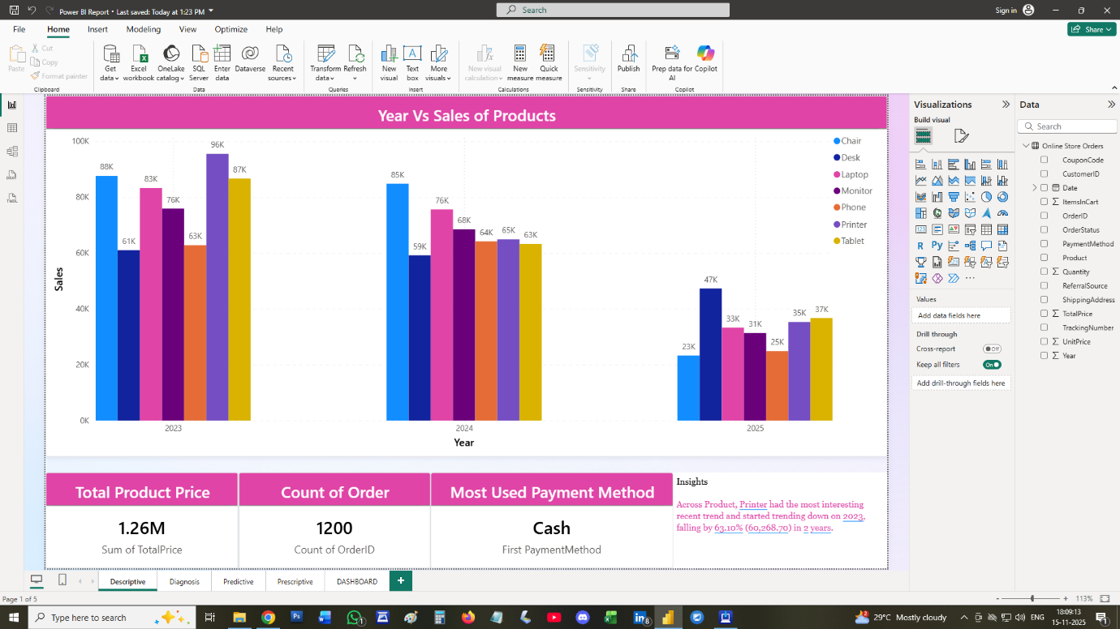
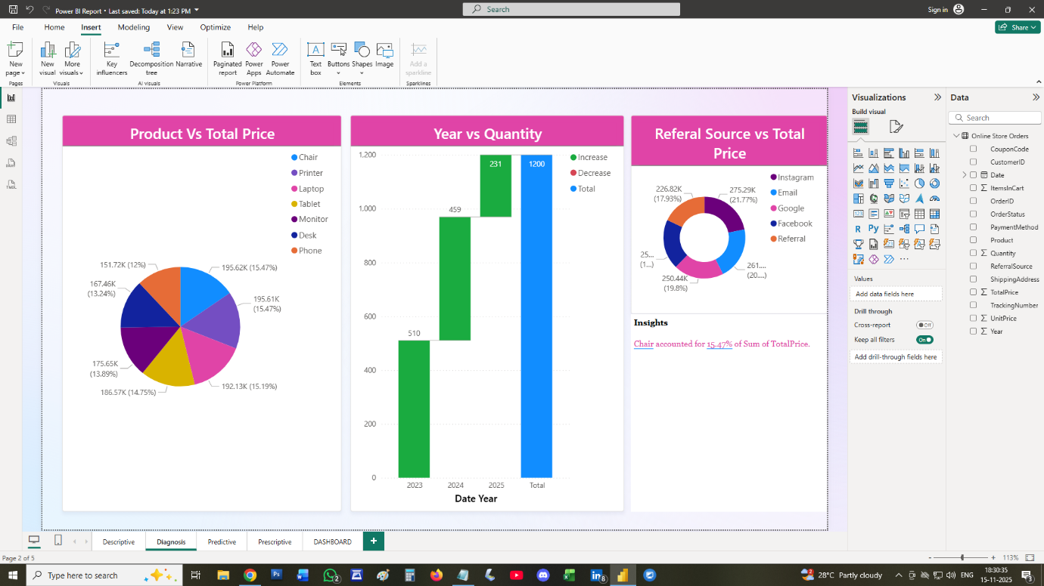

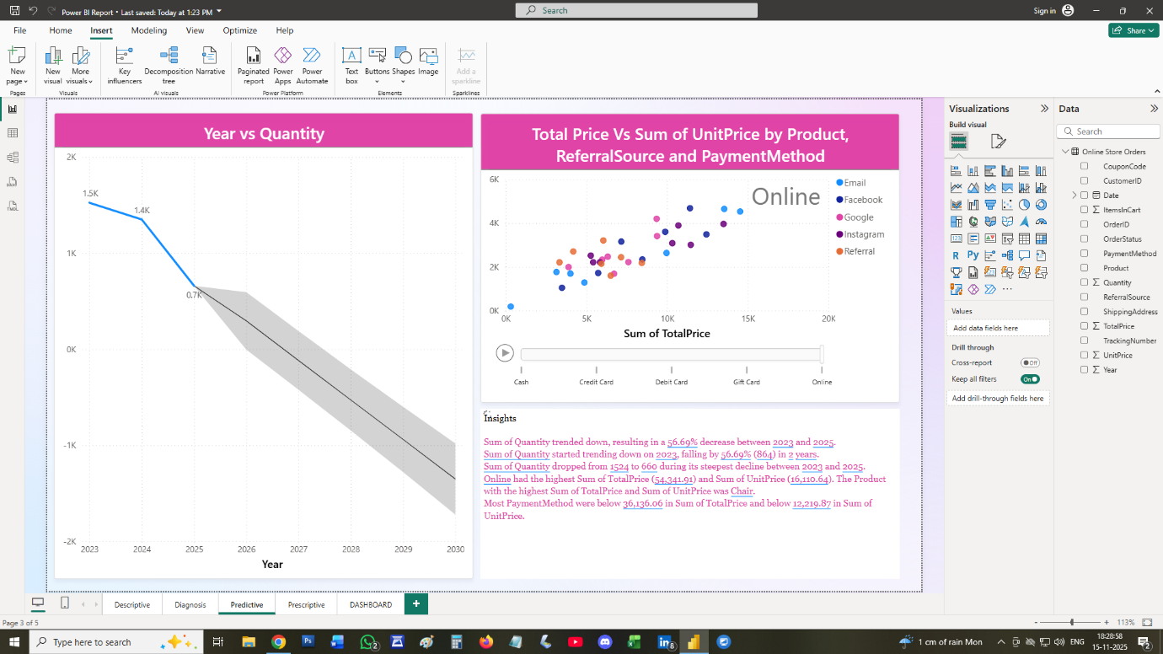
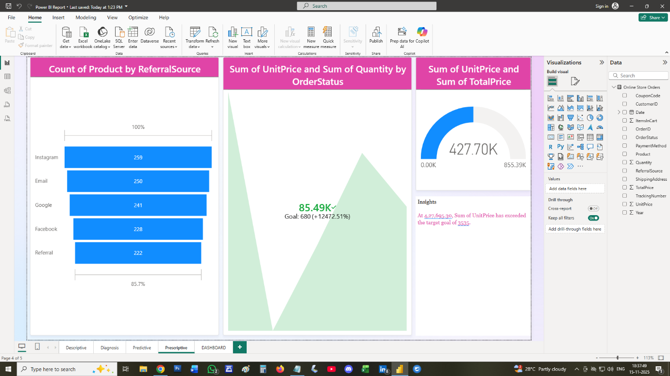

SCREENSHOT OF DASHBOARD /REPORT

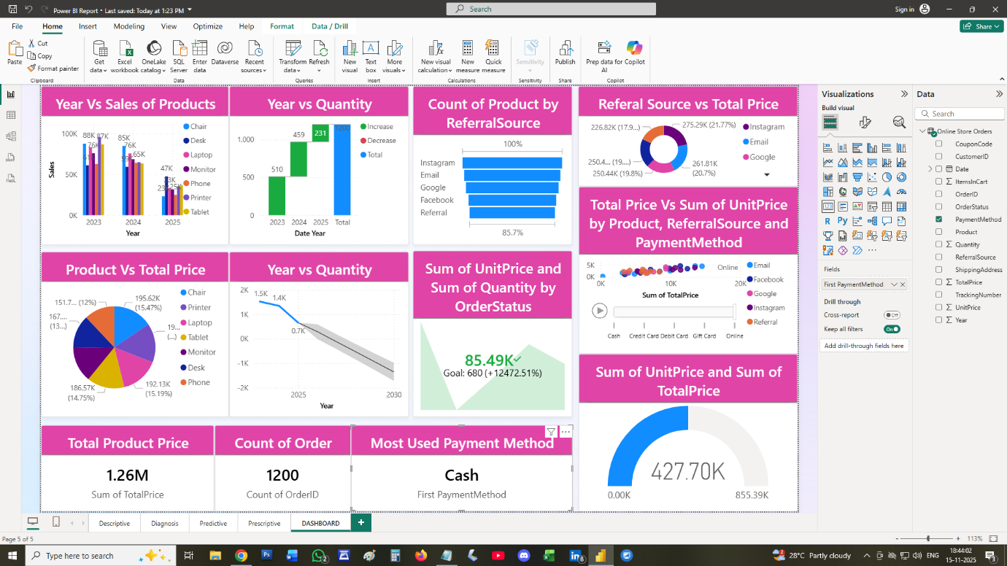

INSIGHTS

DESCRIPTIVE
- Across Product, Printer had tha most interesting recent trend and started trending down on 2023 falling by 63.10% in 2 years
DIAGNOSIS
- Chair accounted for 15.47% of sum of Total Price.
PREDICTIVE
- Sum of Quantity trended down, resulting in a 56.69% decrease between 2023 and 2025
- Sum of Quantity started trending down on 2023, falling by 56.69% in 2 Years
- Sum of Quantity dropped from 1524 to 660 during its steepest decline between 2023 and 2025
- Most Payment method were below 36136 in sum of Total Price and below 12219 in sum of unit price.
PRESCRIPTIVE
- At 427695.30 sum of unit price has exceeded the target goal of 3535.

CONCLUSION
Customer segments such as Government, Channel Partners, and Midmarket display varied purchasing behavior, highlighting opportunities for targeted sales strategies.
Overall, the dataset supports strategic business decisions by identifying high-performing products, profitable markets, key customer segments, and time periods with strong or weak sales performance. It provides a solid foundation for forecasting, inventory planning, pricing optimization, and improving overall business profitability.

